**Katz Amsterdam Foundation ​Shared Measurement Framework:​**  
*How a Thriving Network of Mountain Resort Towns* ​*are Collectively Approaching the* ​*Mental Behavioral Health of their Communities*

Heather Trish, NCC, LPCC, LMHC, LPC​​  
Mountain Mental Behavioral Health Network Director​

[heather@katzamsterdam.org](mailto:heather@katzamsterdam.org)

[www.katzamsterdam.org](http://www.katzamsterdam.org)

**CBHC Learning Objectives & Outcomes**

1. Learn how a thriving multi-state community network works together to share learnings and resources.​
2. Learn how collecting mental behavioral health data is assisting with the strategic programmatic direction of KAF Network Communities.​
3. Consider how collective approaches may be possible in your agencies and communities.

**OVERVIEW​**

The Katz Amsterdam Foundation (KAF) strives to be a catalyst for eliminating inequities, increasing access to opportunity, and improving outcomes for all. We do this work by addressing systemic injustice, racial and social disparities in mental health, reproductive health and civic engagement. As a foundation, our priority is to support community-driven work that meaningfully improves the lives of all individuals and the social well-being of our communities.​

​

**FUNDING PRIORITIES​**

1. Improving Mountain Mental Behavioral Health in Western US Mountain Resort Communities​

* Substance misuse prevention/intervention/treatment​
* Equitable access to MBH services for communities of color​
* KAF SMF Survey Data Project​

1. Ensuring Civic Engagement​
2. Reproductive Freedom & Equity

**KAF Network Communities**

​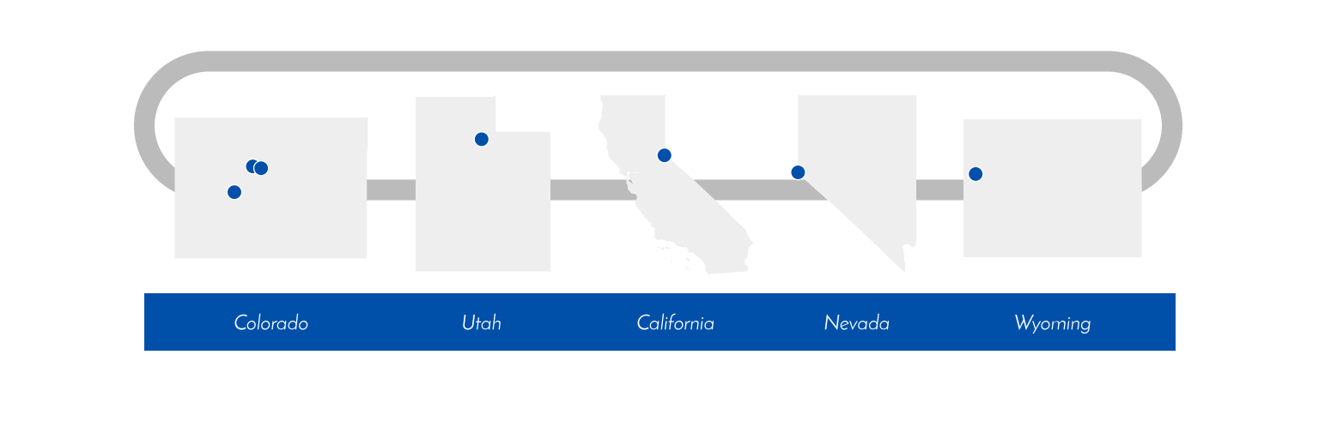

|  |  |
| --- | --- |
| Aspen, CO | Park City, UT |
| Crested Butte, CO | Tahoe Truckee, CA |
| Eagle County, CO | Jackson Hole, WY |
| Summit County, CO | Sun Valley, ID |
| Telluride, CO |  |

**KAF Shared Measurement Framework**

* 5 Challenges​
* 14 Indicators​
* In English & Spanish​

​

Challenge #1 - Social Dynamics and Party Culture​

1. Increase belonging and connection​

2. Decrease the role of substance use in social life​

​

Challenge #2 - Behavioral Health Knowledge and Attitudes​

3. Decreased stigma towards behavioral health​

4. Increase willingness to reach out for behavioral health support​

5. Increase awareness of local mental health resources​

Challenge #3 - Provider Capacity​

6. Increase provider capacity to provide services for unmet behavioral health needs​

7. Increase the diversity of behavioral health providers​

8. Increase behavioral health provider, mental well-being​

​

Challenge #4 - Access and Affordability of Care​

9. Decrease unmet demand for behavioral health services​

10. Decrease barriers experienced when accessing behavioral health care​

11. Increase provider availability and insurance acceptance​

​

Challenge #5 - Adverse Behavioral Health Outcomes​

12. Increased community member mental well-being​

13.  Decreased substance use rates​

14.  Decreased behavioral health related deaths

**KAF SMF Data Dashboard**

(available via [www.katzamsterdam.org](http://www.katzamsterdam.org))

